SMARTLIBRARY MANAGEMENT SYSTEM
Final Project Technical Documentation
TABLE OF CONTENTS
1. Introduction
2. Project Overview
3. System Requirements
4. Backend Programming Design (Python OOP)
UML/ERD
5. Database Implementation (PostgreSQL)
6. GUI Implementation (PyQt5)
7. Business Rules & System Validation
8. System Integration
9. Testing & Debugging
10. Collaboration & Version Control
11. Security Considerations
12. System Deployment
13. Limitations
14. Future Enhancements
15. Conclusion
16. Appendices (Code Samples)

1. INTRODUCTION
SmartLibrary is a desktop-based Library Management System developed to automate the daily operations of Limkokwing University’s central library. The system allows management of books, authors, members, loans, and book clubs using a structured and secure software approach.

The application was developed using Python with Object-Oriented Programming, PostgreSQL for database storage, PyQt5 for the graphical user interface, and psycopg2 for database connectivity.

2. PROJECT OVERVIEW

The SmartLibrary system supports two main user roles:
• Librarian
• Member

The system allows members to search books, borrow and return books, and join book clubs. Librarians are responsible for managing books, authors, members, book clubs, and system monitoring through a dashboard.
The system ensures that data transactions are accurate, secure, and consistent at all times.

3. SYSTEM REQUIREMENTS

3.1 Functional Requirements

• User authentication with role-based access
• Add, update, delete, and view books
• Manage authors and book records
• Register and manage library members
• Borrow and return books
• Enforce maximum of 3 active loans per member
• Automatic due date generation (7 days)
• Book availability tracking
• Book club creation and management
• Dashboard summary of system statistics

3.2 Non-Functional Requirements

• High system reliability
• Secure database connections
• Fast response time
• Easy-to-use graphical interface
• Data integrity and consistency
• Scalability for future expansion

4. BACKEND PROGRAMMING DESIGN (PYTHON OOP)

The backend logic follows Object-Oriented Programming principles and is implemented using Python.

4.1 Core Classes

• User
• Librarian (inherits from User)
• Member (inherits from User)
• Book
• Author
• Loan
• BookClub
• Role

ERD DIAGRAM
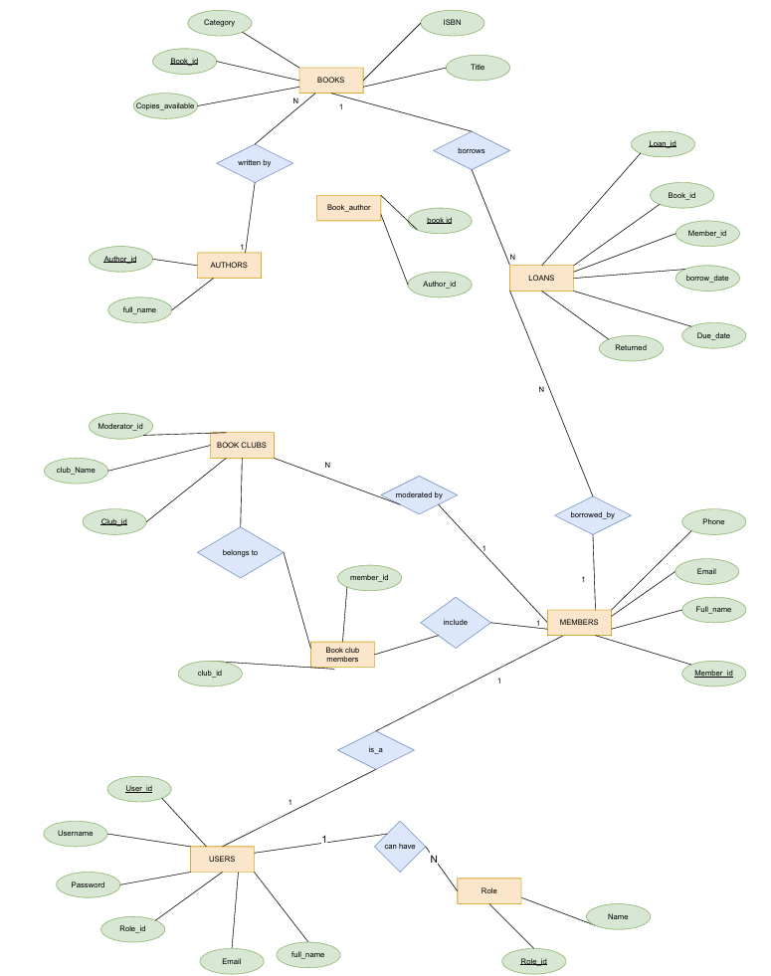

UML CLASS DIAGRAM
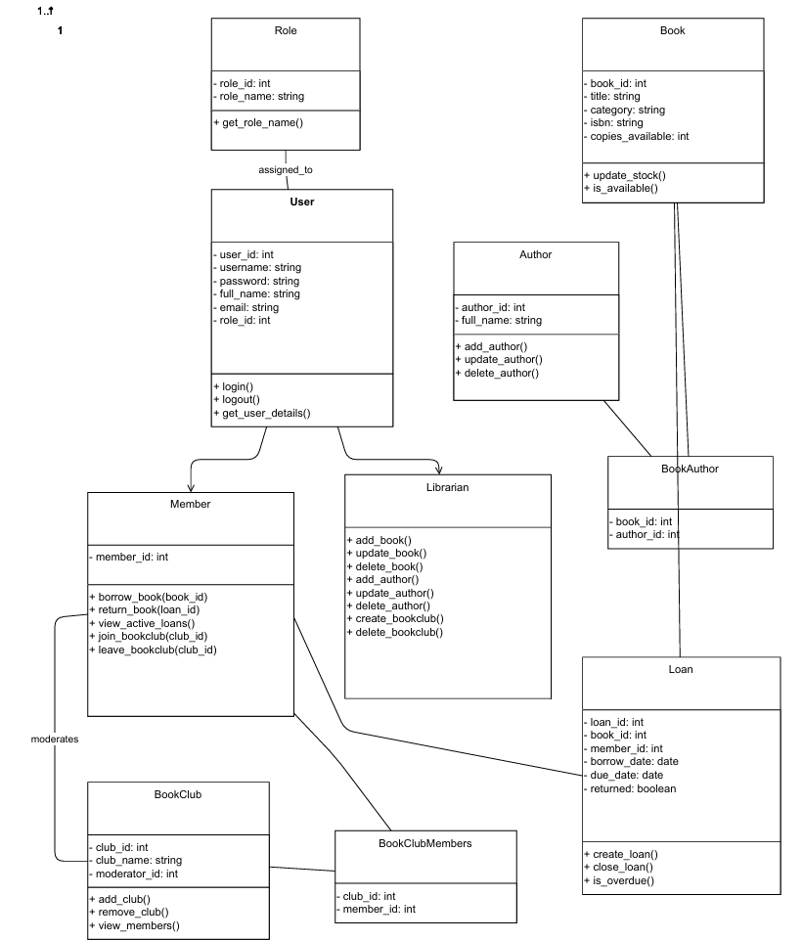
4.2 Encapsulation

Private attributes are used to protect sensitive data using underscores (_). Getter and setter methods are implemented using `@property` decorators.

4.3 Inheritance
The User class is the parent class. Member and Librarian inherit all authentication and user data methods from User.
4.4 Data Access Layer
DAOs (Data Access Objects) are used to separate business logic from database operations. All SQL commands are executed using parameterized queries for security.

5. DATABASE IMPLEMENTATION (POSTGRESQL)
The database consists of the following main tables:
• role
• user
• book
• author
• book_author
• loan
• bookclub
• bookclubmembers

Relationships include:
• One-to-Many between Role and User
• Many-to-Many between Book and Author
• One-to-Many between Member and Loan
• Many-to-Many between BookClub and Members

Primary keys and foreign keys ensure database integrity.

6. GUI IMPLEMENTATION (PYQT5)
The graphical interface was developed using PyQt5
Main application screens:
• Login Screen
• Dashboard
• Book Catalog
• Loan Management
• Book Management
• Author Management
• Book Club Management

Navigation is handled through stacked widgets and sidebar menus.

7. BUSINESS RULES & SYSTEM VALIDATION

• A member cannot borrow more than 3 books at a time
• A loan duration is strictly 7 days
• A book must have at least one copy available to be borrowed
• Returned books automatically increase available stock
• Only librarians can modify books and authors
All rules are enforced at backend level for data security.

8. SYSTEM INTEGRATION
The system integrates:
• PyQt5 GUI → Python Backend
• Python Backend → PostgreSQL via psycopg2
Real-time updates occur instantly when a borrow or return operation is performed.
9. TESTING & DEBUGGING
Testing includes:
• Unit testing for backend methods
• Integration testing for database operations
• Manual GUI usability testing
• Loan transaction verification
• Borrowing limit testing
• Data rollback testing for failed transactions

10. COLLABORATION & VERSION CONTROL
The project was managed using Git and GitHub.
• Feature branches used:
- feature/login
- feature/borrow
- feature/dashboard

• Code reviewed using pull requests
• CI pipelines used for:
- Linting with flake8
- Unit testing
- Migration testing

11. SECURITY CONSIDERATIONS
• Parameterized SQL queries used
• Role-based access control implemented
• Database credentials protected
• Transaction rollback used for failed operations
• Future upgrade: Password hashing

12. SYSTEM DEPLOYMENT
• PostgreSQL installed and configured
• Python virtual environment created
• Dependencies installed via `requirements.txt`
• Database migrations executed
• Application launched via `gui_app.py`

13. LIMITATIONS
• No biometric login
• No email notifications
• Desktop-only application
• No mobile access
• Passwords not hashed in current version

14. FUTURE ENHANCEMENTS
• Password encryption
• Email alerts for overdue books
• Mobile application support
• Integration with RFID scanners
• Cloud database hosting

15. CONCLUSION
The SmartLibrary Management System successfully meets all the functional and technical requirements for automating university library operations. The project demonstrates effective application of Object-Oriented Programming, database design, GUI development, system integration, and collaboration tools. The system is reliable, scalable, and suitable for real-world academic institutions.

16. APPENDICES

Appendix A: Loan Transaction Code (Sample)
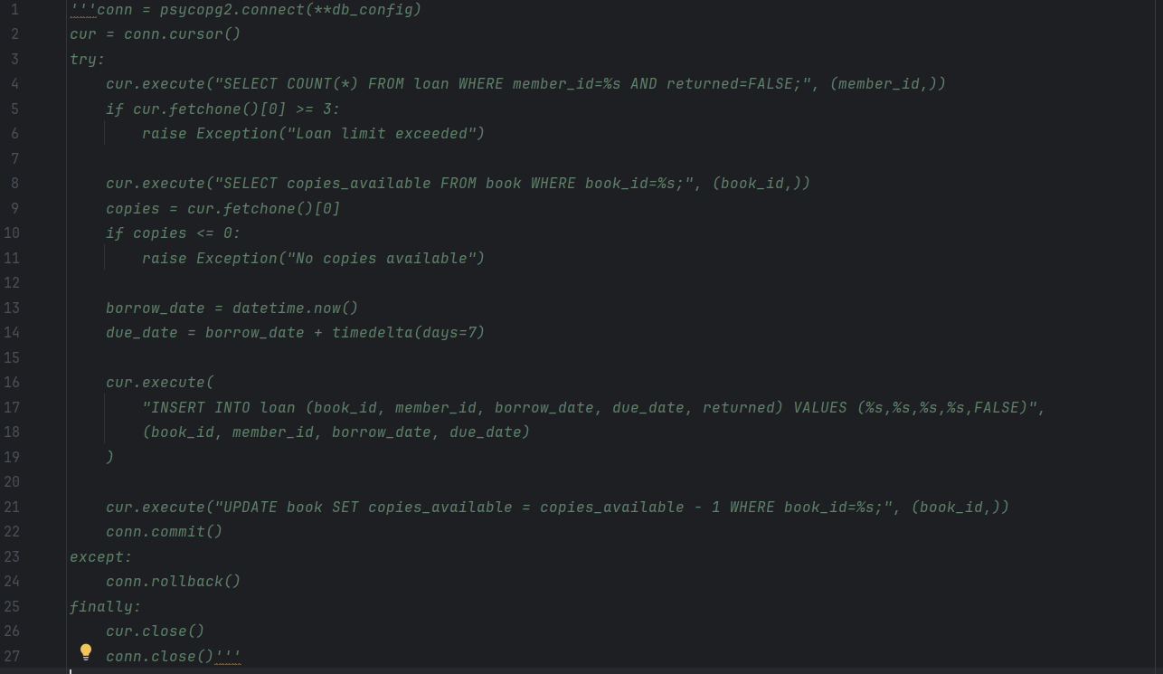

Appendix B: Database Table Example
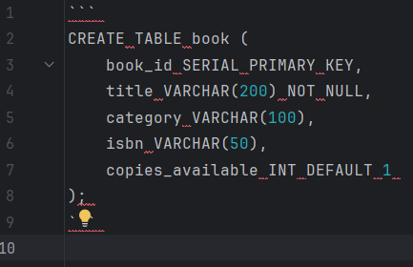

END OF DOCUMENT

